CURRICULUM VITAE
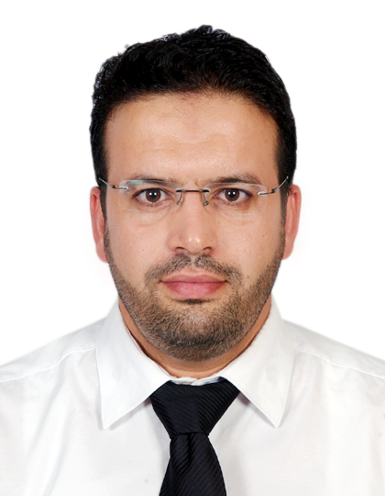
Name : RIDHA LATRACH
Marital status : Married
Number of Children: 02
Nationality: Tunisian
Date & Place of Birth : 01/07/1977 Medenine Tunisia
Address: Flat 02 Building 629G Road 5515 Area 255
Galali-kingdom of Bahrain
Phone number:
(Bahrain) 00973 36 885 774
(Tunisia) 00216 96 697 153

E-mail: Ridha0107@yahoo.com

EDUCATION:

- 2000-2001 :
Academic Degree:
Bachelor: Sciences of management.
Grade: Cum laude
Establishment: Tunis Higer School of Commerce (ESCT) (University of Manouba)
Thesis:
  - Subject: Financial liberalization and banker's function: Realities and Perspective. Internation Arab Bank of Tunisia (BIAT) case.
  - Grade: Magna cum laude

PROFESSIONAL EXPERIENCE :

- Since April 2008 - Present :
Position held : Professional Accountant
Company Name : Electericity & Water Authority Kingdom of Bahrain (EWA Bahrain)
Section : General Accounting- Costing Control Unit.
Experience of ERP : SAP
- Tasks carried out:
- Cost analysis and certifying cost for capitalization of recurrent projects of electricity & water distribution and street lighting
- Assigned to ensure proper accounting of capital projects using Internal Orders in SAP (CO- module).
- Cost analysis on monthly basis to verify if costs are correctly expensed out.
- Creation, settlemet & analysis of Internal Orders
- Download Internal Requisition (documents of materials issued from Central Store) from FMIS (Oracle) and upload to SAP.
- Monthly reporting
- Imparted on-job training to fresh graduate trainees and assistance unit staff.
- Attending to auditors queries and providing them with required information.

Section : Payment section

- Skills & knowledge gained :
- Procedures of invoice payments (from receiving invoices until preparing proposal for payments (recurrent & project payment))
- Creation vendor account and direct bank transfer
- Different types of contracts (renewable, MTC, Major projects, Lum Sum contracts & retention)
- Petty Cash and different staff benefit payments
- Preparation of proposal of payment to be send to treasury section

- June 2003 – March 2008 :
Position held : Administrative and financial manager
Company Name : Center of Information, Training, Studies and Documentation on Associations C.I.F.E.D.A, Tunis
Tasks carried out:
- Finalization of financial statements and preparation of year end audit schedules.
- Inventory managment.
- Reconciliation (Bank, Debtors & Creditors).
- Preparation of Cash Payment, Cheque Payment, Vouchers & Journal vouchers with proper allocation to the respective account heads and entering in the accounting software.
  - Human Resources Management : Preparation of Payroll, maintaining and updating files of staff, doing all processes of recruitement.
  - Preparing the Annual Budget : Operating & Capital Budget, preparing the follow up of the expenditures monthly
- Maintain Fixed Assets register with addition and disposals.
- Organisation of meetings of Directors Board and preparing the reports
- Reply to all correspondences issued by the ministries and all government departments.

- From the 01/02/2003 to the 30/05/2003:
- Position held : Auditor
- Company Name : Office of Management and Accounting.B.C.G, Tunis. TUNISIA

- Tasks carried out:
- Missions of Auditing.
- Financial accounting.

Training:

- July 2000, Regional direction of National Agricultural Bank in Médenine , Tunisia.
- Training in English Language at Bourguiba School Tunis. (4 years)
- Certificate of achievement seminar in : "The Power of Self-Confidence" from the Canadian Training Center of Human Development (7th to 10th September 2005).
- Training course in : SAP_ Training Section EWA Bahrain.
- Training course in : "Skills of preparation and writing banking and financial reports" ait Center (26th to 29th January 2009).
- Training course in : Access_ Training Section EWA Bahrain. (22nd to 29th April 2009)
- Attendance in courses of CMA (Part I & II ) in Bahrain Institute of Banking & Finance (BIBF) (2012-2013)

COMPUTER SKILLS:

Word, Excel, PowerPoint, Access , Internet.

Personal SKILLS:

Teamwork, Communication, Self-confidence, Self-motivation, Responsibility, Flexibility, Integrity, Continuous Learning

LANGUAGES:

Languages | Read | Written | Spoken
Arabic | Well | Well | Well
English | Well | Well | Well
French | Well | Well | Well

